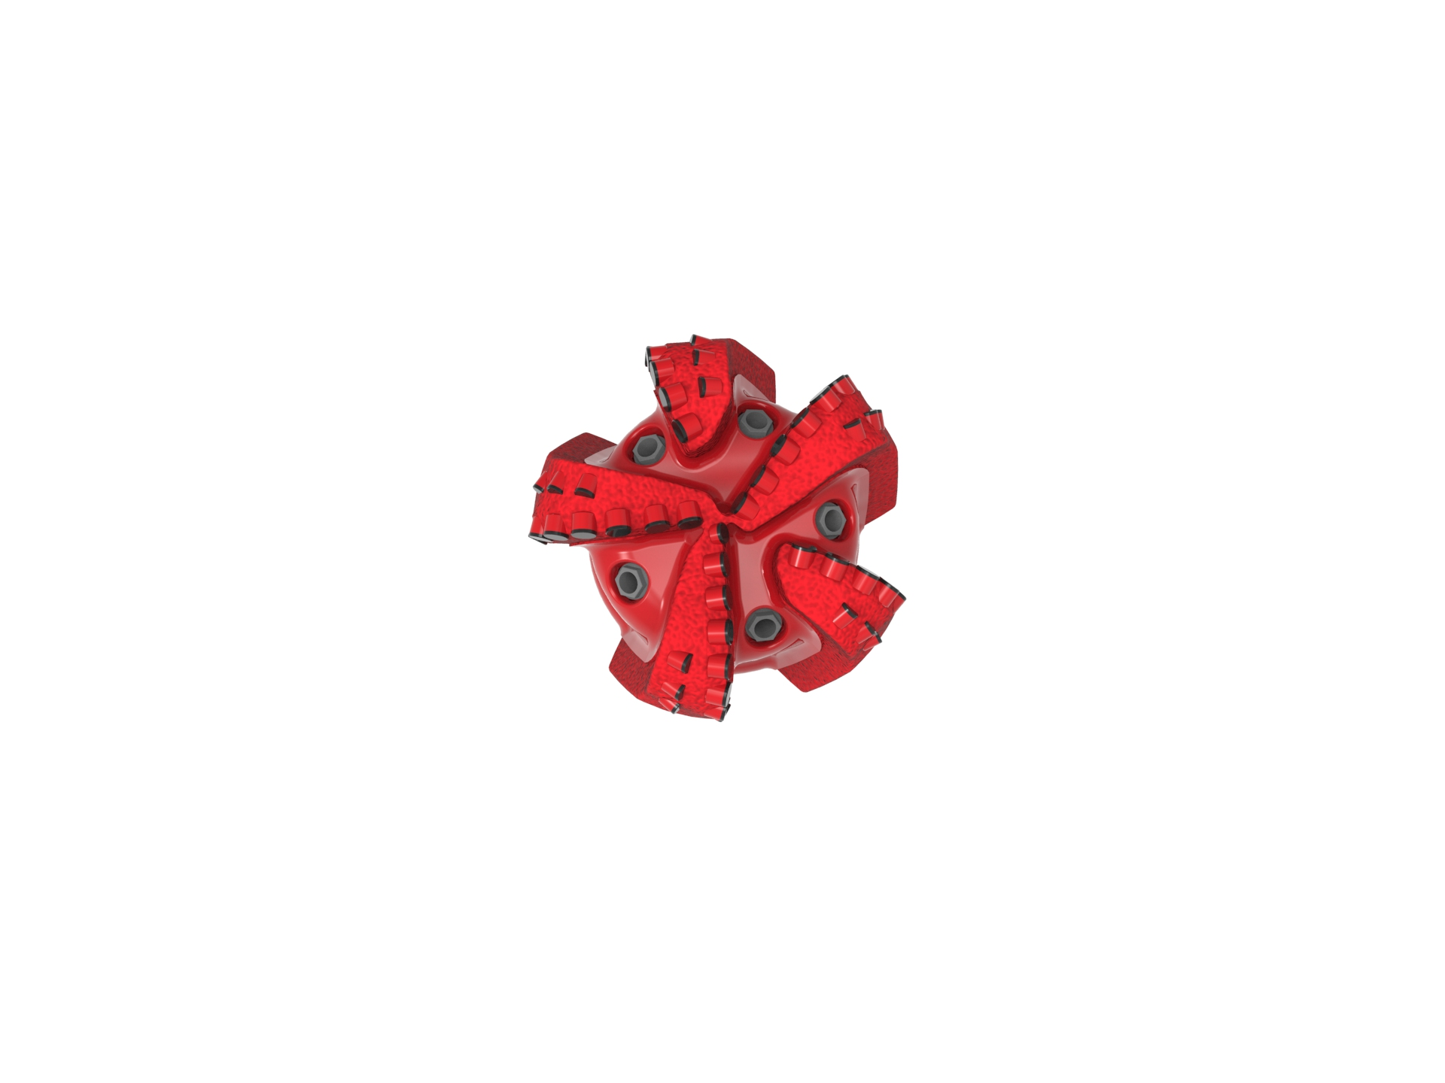
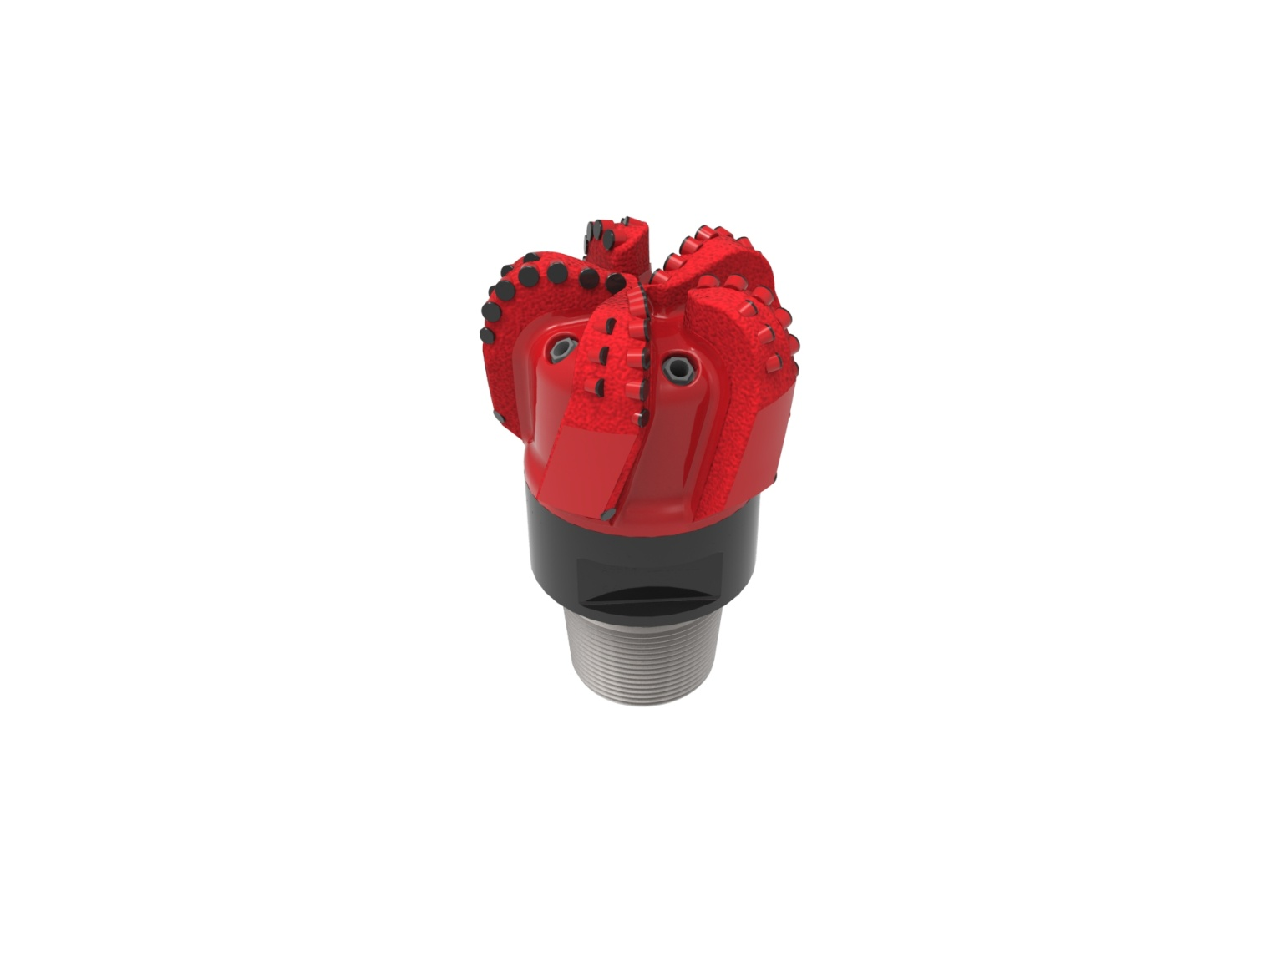

Drill Bit Specifications:
Cutter Size (Primary, Sec) | 5/8”,1/2”
Cutter Count (Total, Gage, Back Ream) | 54,5,5
Blade Count | 5
Gage Length (Inches) | 3.00
Nozzle Count (Primary, Sec.) | 5
Nozzle Series (Primary, Sec.) | 60
JSA (Sq. Inches) | 20.69
Max. TFA (Sq. Inches) | 1.86
Operating Parameters:
Max. Hydraulic Flow Rate (GPM) | 650
Max. Weight on Bit (1,000 Lbs.) | 60
Make-up Torque (ft/lbs) | 40,563
Nominal Dimensions:
Overall Length (Inches) | *15.92
Make Up Length (Inches) | *11.04
Bit Breaker | SKB-21011
Connection | Ø6-5/8" API Reg.
Approx. Weight (Lbs.)  *Long tool joint available upon request (adds 6” to fishing neck, makeup and overall length, and 64 lbs to approximate weight). | *145

Standard Features:

- Premium grade cutters maximize ROP and Life
- Large open face volume assists cuttings removal
- Five nozzles optimize blade cleaning and cuttings removal

516-XR(BR) Nomenclature Explained:

• | 5 | = | Number of Blades
• | 16 | = | Primary Cutter Size (16mm)
• | XR+ | = | Backup Cutters
• | BR+ | = | Back Reaming Cutters


